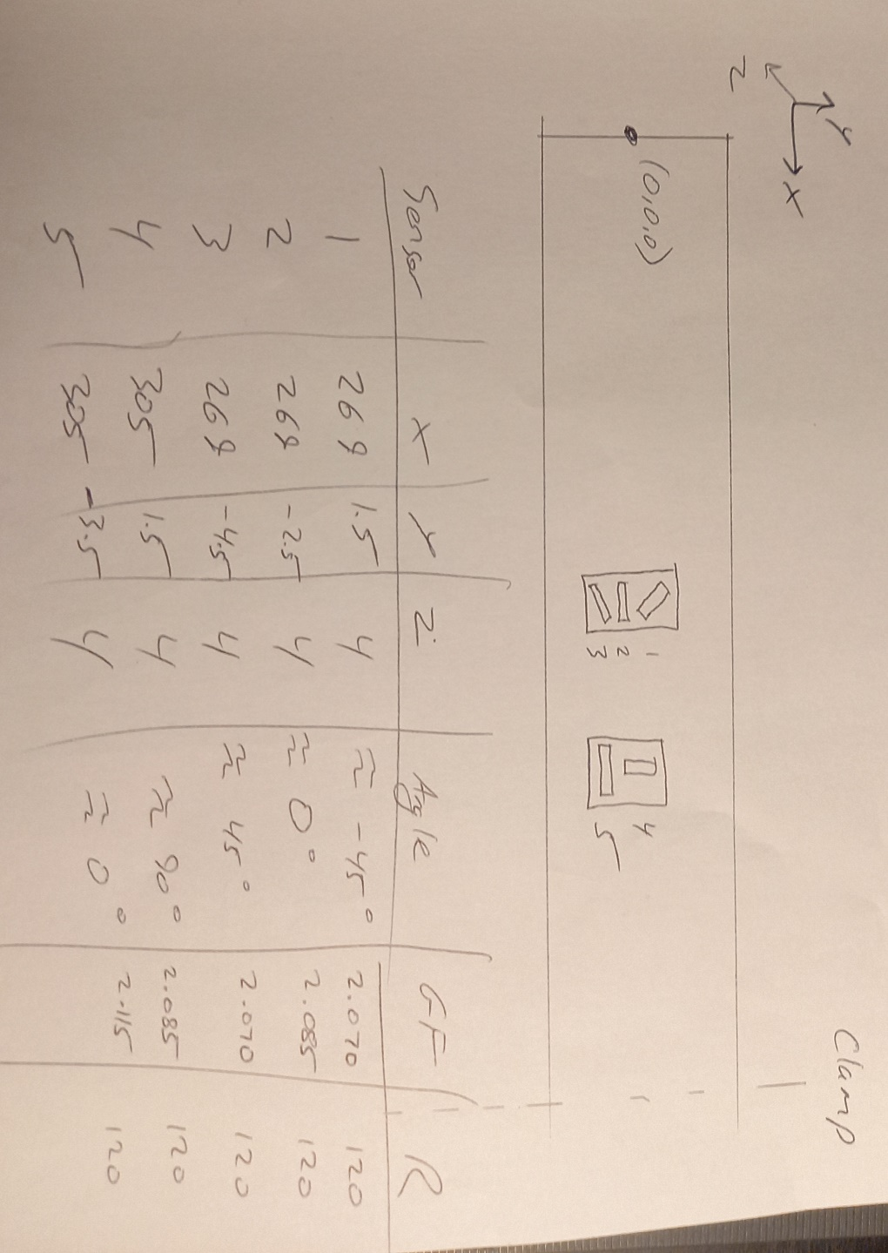**21.02.24 Report**

**Strain gauges on 25mm and 50mm beam**

Note that strain gauge/FEA comparisons are made on different graphs to the Kistler/FEA comparisons- because the Kistler and SGs are located at different points. The FEA predictions are the strain at each sensor location.

**Strain gauges on 25mm beam**

Figure 1. Rough diagram with strain gauge labelling for 25mm beam

Setup info:

1. Labview settings are all the same as were used in previous experiments
2. Beam was clamped in position 1 for all tests i.e. 415mm effective beam length
3. Loading was applied with weights sitting horizontally at the beam end.

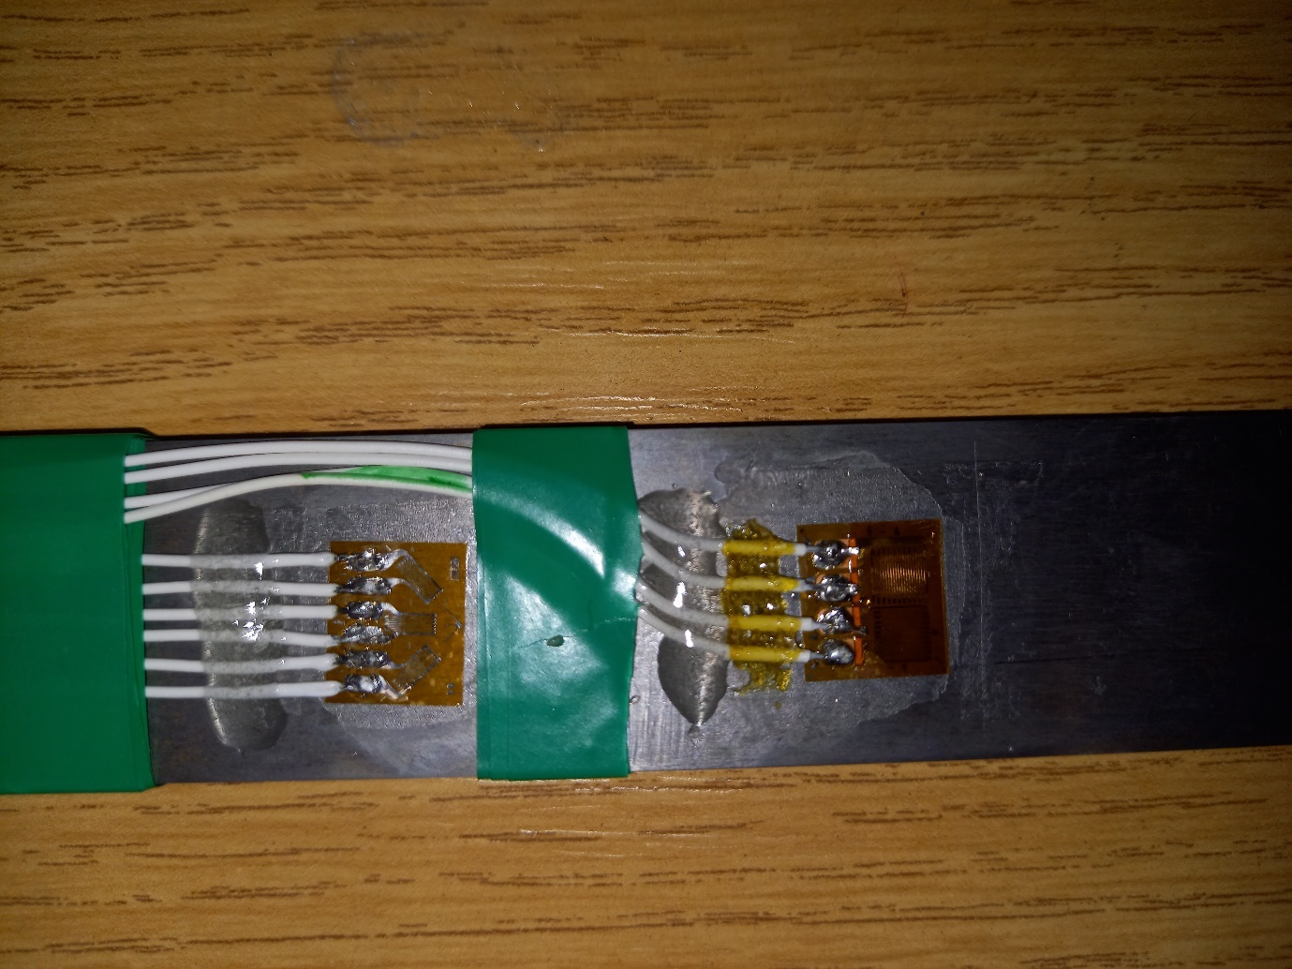

Figure 2. Strain gauges installed on 25mm beam

|  |  |  |  |  |  |  |
| --- | --- | --- | --- | --- | --- | --- |
| **Sensor** | **X coordinate** | **Y coordinate** | **Z coordinate** | **Axial angle** | **Gauge Factor** | **Resistance** |
| 1 | 269 | 2.1  (10.4 from top) | 4 | -45 | 2.070 | 120 |
| 2 | 269 | -1  (13.5 from top) | 4 | 0 | 2.085 | 120 |
| 3 | 269 | -4.7  (17.2 from top) | 4 | 45 | 2.070 | 120 |
| 4 | 305 | -1  (11.5 from top) | 4 | 90 | 2.085 | 120 |
| 5 | 305 | -4.5  (16 from top) | 4 | 0 | 2.115 | 120 |

Table 1. Setup information for gauges on 25mm beam

|  |  |  |  |  |  |  |  |
| --- | --- | --- | --- | --- | --- | --- | --- |
| **Load (g)** | **Load (N)** | **Gauge 1 (µε)** | **Gauge 2 (µε)** | **Gauge 3 (µε)** | **Gauge 4 (µε)** | **Gauge 5 (µε)** | **FEA** |
| 100 | 0.981 | -2.9 | 5.2 | 18.1 | 8.9 | 18.2 | 4.9 |
| 200 | 1.962 | -11.0 | 8.2 | 34.7 | 16.6 | 39.6 | 9.8 |
| 300 | 2.943 | -14.8 | 15.8 | 51.5 | 22.9 | 60.8 | 14.7 |
| 400 | 3.924 | -20.5 | 22.4 | 70.2 | 30.0 | 78.2 | 19.6 |
| 500 | 4.905 | -25.0 | 23.9 | 83.5 | 35.3 | 91.3 | 24.5 |
| 600 | 5.886 | -32.4 | 31.2 | 103.9 | 44.5 | 116.8 | 29.4 |
| 700 | 6.867 | -35.5 | 37.5 | 123.5 | 53.7 | 138.8 | 34.3 |
| 800 | 7.848 | -42.2 | 42.1 | 138.7 | 59.1 | 154.3 | 39.3 |
| 900 | 8.829 | -46.9 | 46.8 | 156.3 | 66.6 | 174.4 | 44.2 |

Table 2. Comparison of strain gauge 1-5 results and FEA predictions for 25mm beam

Gauges 2 and 5 are the important sensors for this beam- running parallel with the beam axis.

Note how gauges 3, 4 and 5 give much higher strain than you’d expect here

Figure 3. Comparison of strain gauge 2 results and FEA predictions for 25mm beam

|  |  |  |  |  |  |
| --- | --- | --- | --- | --- | --- |
| **Load (g)** | **Load (N)** | **Gauge 2 (µε)** | **FEA (µε)** | **Difference  (µε)** | **Difference (%)** |
| 100 | 0.981 | 5.2 | 4.9 | -0.3 | -5% |
| 200 | 1.962 | 8.2 | 9.8 | 1.6 | 19% |
| 300 | 2.943 | 15.8 | 14.7 | -1.1 | -7% |
| 400 | 3.924 | 22.4 | 19.6 | -2.8 | -12% |
| 500 | 4.905 | 23.9 | 24.5 | 0.6 | 3% |
| 600 | 5.886 | 31.2 | 29.4 | -1.8 | -6% |
| 700 | 6.867 | 37.5 | 34.3 | -3.2 | -9% |
| 800 | 7.848 | 42.1 | 39.3 | -2.8 | -7% |
| 900 | 8.829 | 46.8 | 44.2 | -2.6 | -6% |

Table 3. Comparison of strain gauge 2 results and FEA predictions for 25mm beam

Figure 4. Comparison of strain gauge 5 results and FEA predictions for 25mm beam

|  |  |  |  |  |  |
| --- | --- | --- | --- | --- | --- |
| **Load (g)** | **Load (N)** | **Gauge 5 (µε)** | **FEA (µε)** | **Difference  (µε)** | **Difference (%)** |
| 100 | 0.981 | 18.2 | 6.0 | -12.2 | -67% |
| 200 | 1.962 | 39.6 | 11.9 | -27.7 | -70% |
| 300 | 2.943 | 60.8 | 17.9 | -42.9 | -71% |
| 400 | 3.924 | 78.2 | 23.8 | -54.4 | -70% |
| 500 | 4.905 | 91.3 | 29.8 | -61.5 | -67% |
| 600 | 5.886 | 116.8 | 35.8 | -81.0 | -69% |
| 700 | 6.867 | 138.8 | 41.7 | -97.1 | -70% |
| 800 | 7.848 | 154.3 | 47.7 | -106.6 | -69% |
| 900 | 8.829 | 174.4 | 53.6 | -120.8 | -69% |

Table 4. Comparison of strain gauge 5 results and FEA predictions for 25mm beam

|  |  |  |
| --- | --- | --- |
| **Gauge 4 (µε)** | **Gauge 5 (µε)** | **Poisson ratio** |
| 8.9 | 18.2 | -0.49 |
| 16.6 | 39.6 | -0.42 |
| 22.9 | 60.8 | -0.38 |
| 30.0 | 78.2 | -0.38 |
| 35.3 | 91.3 | -0.39 |
| 44.5 | 116.8 | -0.38 |
| 53.7 | 138.8 | -0.39 |
| 59.1 | 154.3 | -0.38 |
| 66.6 | 174.4 | -0.38 |

Table 5. Poisson ratio calculations for 25mm beam

Note- The calculated Poisson ratio seems very high here

**Kistler on 25mm beam (From 13.02.24)**

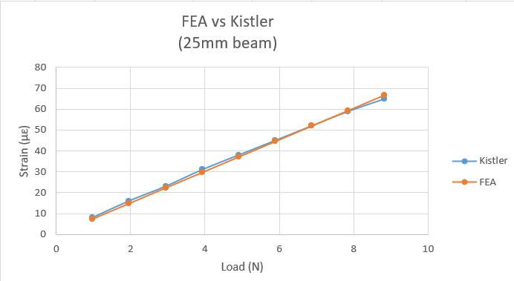

Figure 5. Comparison of Kistler results and FEA predictions for 25mm beam

|  |  |  |  |  |  |
| --- | --- | --- | --- | --- | --- |
| **Load (g)** | **Load (N)** | **Kistler (µε)** | **FEA (µε)** | **Difference  (µε)** | **Difference (%)** |
| 100 | 0.981 | 8 | 7.4 | -0.6 | -7% |
| 200 | 1.962 | 16 | 14.8 | -1.2 | -7% |
| 300 | 2.943 | 23 | 22.3 | -0.7 | -3% |
| 400 | 3.924 | 31 | 29.7 | -1.3 | -4% |
| 500 | 4.905 | 38 | 37.1 | -0.9 | -2% |
| 600 | 5.886 | 45 | 44.5 | -0.5 | -1% |
| 700 | 6.867 | 52 | 51.9 | -0.1 | 0% |
| 800 | 7.848 | 59 | 59.4 | 0.4 | 1% |
| 900 | 8.829 | 65 | 66.8 | 1.8 | 3% |

Table 6. Comparison of Kistler results and FEA predictions for 25mm beam

**Strain gauges on 50mm beam**

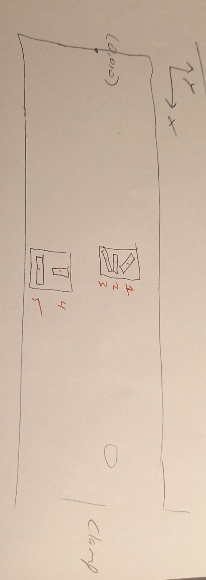

Figure 6. Rough diagram with strain gauge labelling for 50mm beam

**Revised coordinates in red**

|  |  |  |  |  |  |  |
| --- | --- | --- | --- | --- | --- | --- |
| **Sensor** | **X coordinate** | **Y coordinate** | **Z coordinate** | **Axial angle** | **Gauge Factor** | **Resistance** |
| 1 | 260 | 9 | 5 | -45 | 2.070 | 120 |
| 2 | 260 | 7 (?) | 5 | 0 | 2.085 | 120 |
| 3 | 260 | 5 | 5 | 45 | 2.070 | 120 |
| 4 | 260 | -8 | 5 | 90 | 2.085 | 120 |
| 5 | 260 | -15 (?) | 5 | 0 | 2.115 | 120 |

Table 7. Information for strain gauges installed on 50mm beam

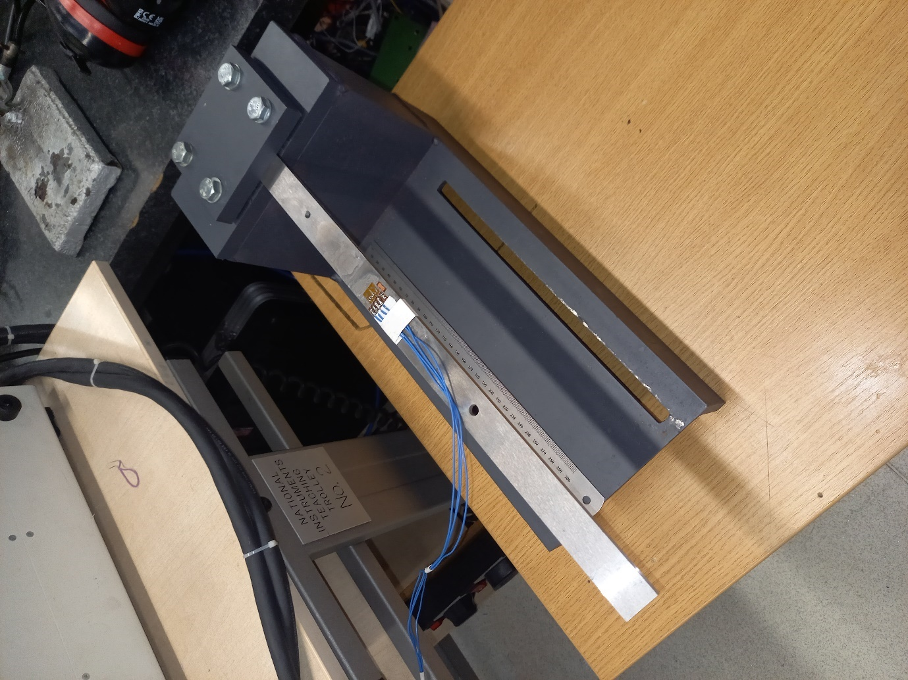

Figure 7. 50mm beam clamped in test rig

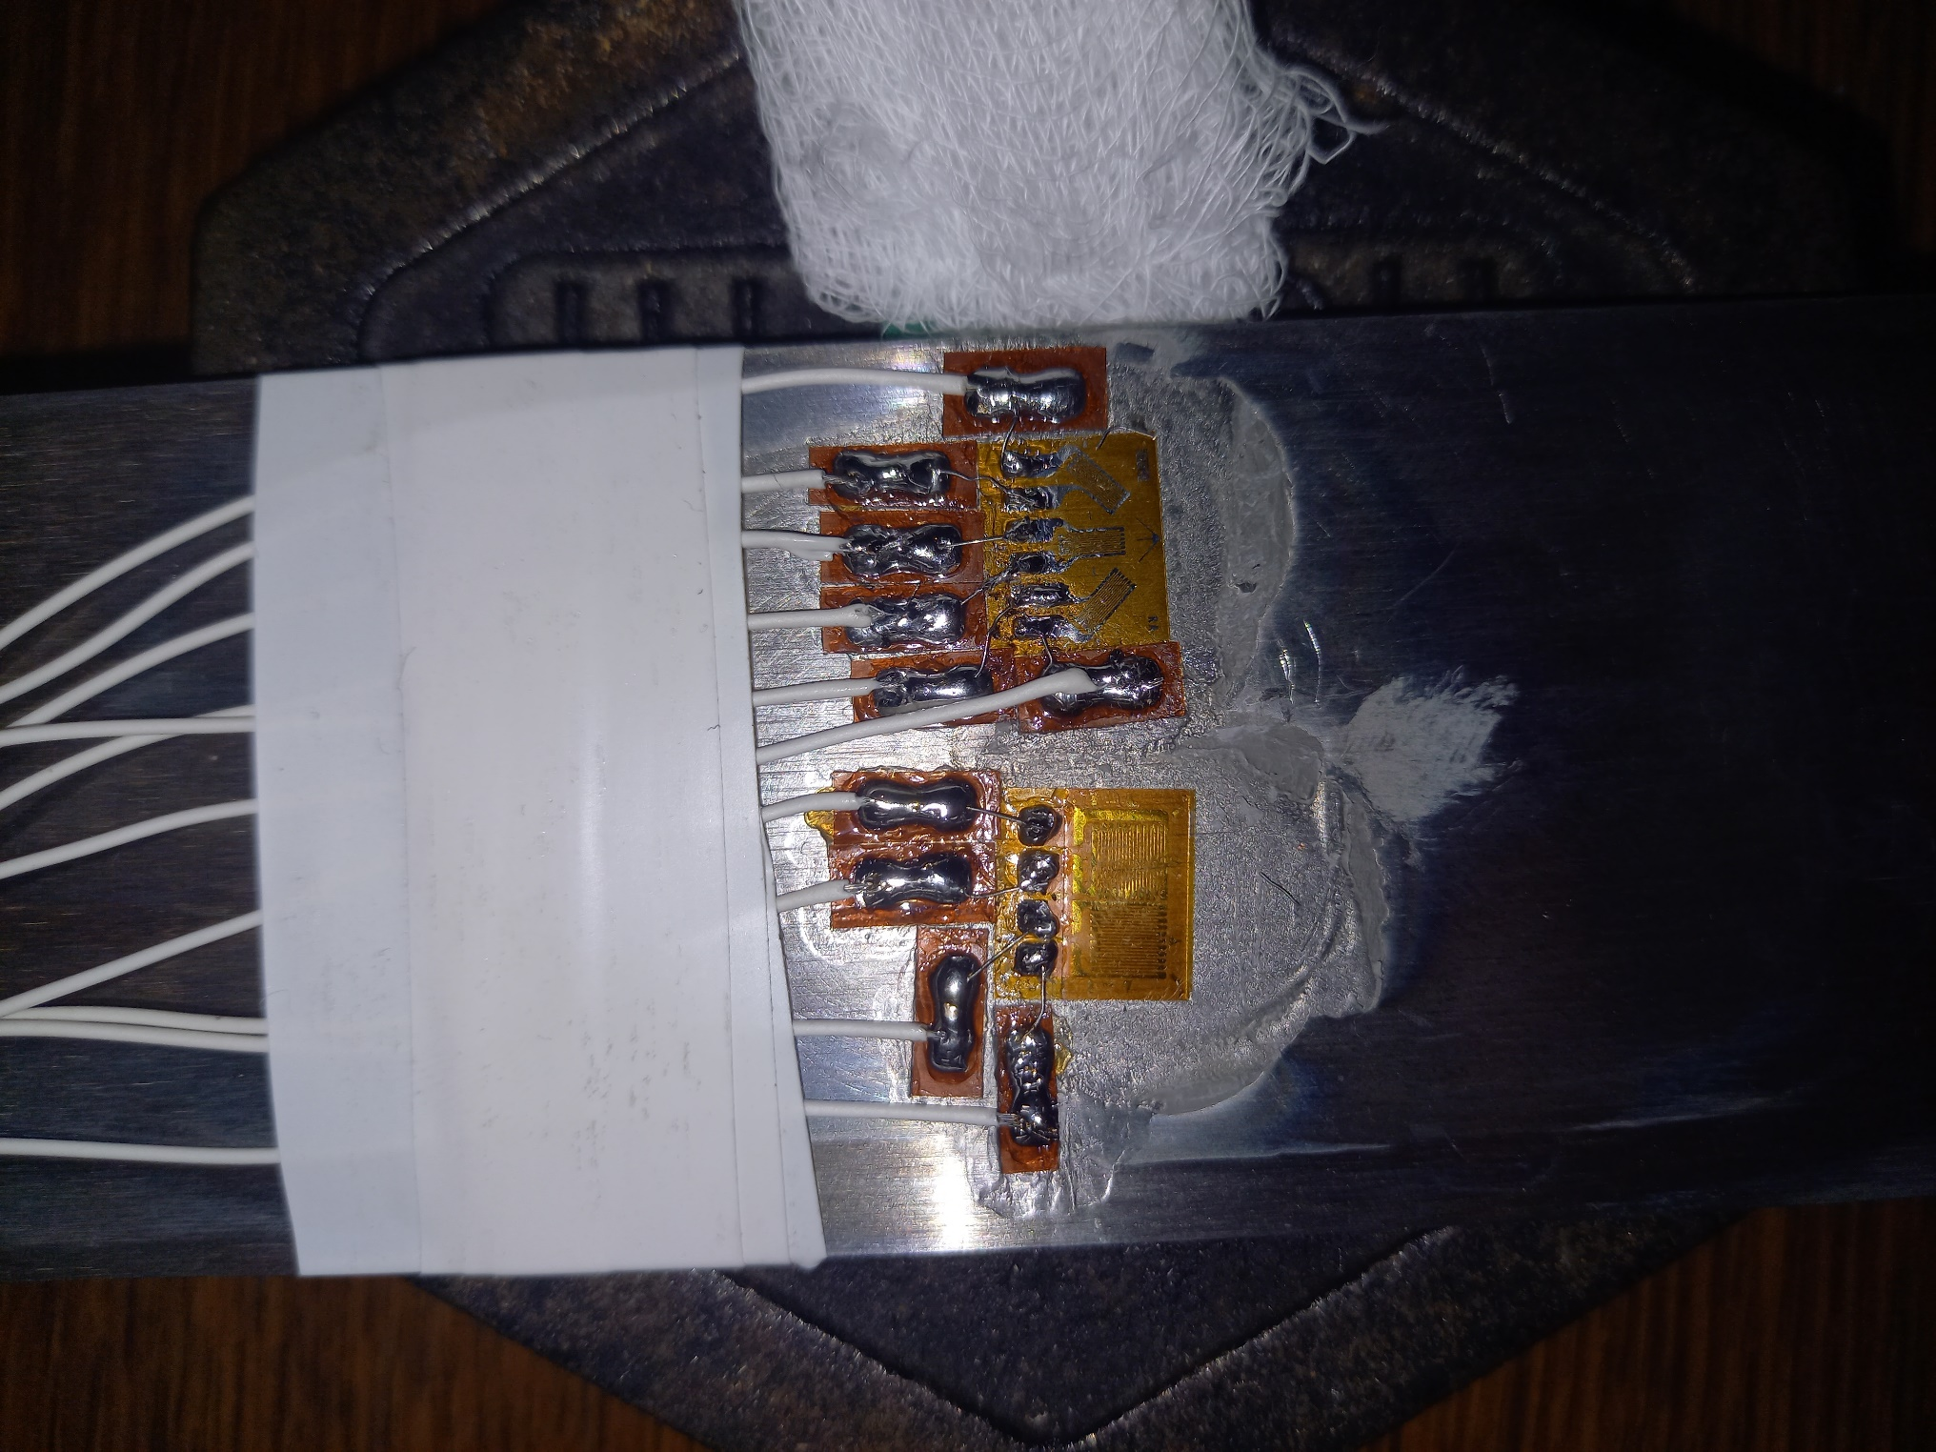

Figure 8. Strain gauges installed on beam

Note that no results were obtained for gauges 4 and 5 here. It was originally thought that these gauges were broken, but it was found that the labview module was at fault. The two channels that these guages were plugged into were not working. I will test these two guages with a micrometer to check that they are definitely working

|  |  |  |  |  |  |
| --- | --- | --- | --- | --- | --- |
| **Load (g)** | **Load (N)** | **Gauge 1 (µε)** | **Gauge 2 (µε)** | **Gauge 3 (µε)** | **FEA (µε)** |
| 100 | 0.981 | 2.6 | 7.7 | 3.9 | 5.2 |
| 200 | 1.962 | 4.5 | 10.0 | 2.5 | 10.4 |
| 300 | 2.943 | 8.2 | 17.3 | 7.8 | 15.7 |
| 400 | 3.924 | 10.1 | 20.6 | 6.9 | 20.9 |
| 500 | 4.905 | 10.5 | 24.8 | 6.5 | 26.1 |
| 600 | 5.886 | 13.8 | 32.9 | 12.3 | 31.3 |
| 700 | 6.867 | 16.3 | 38.2 | 13.7 | 36.6 |
| 800 | 7.848 | 18.0 | 43.5 | 15.2 | 41.8 |
| 900 | 8.829 | 19.4 | 48.3 | 17.5 | 47.0 |

Table 8. Comparison of strain gauge 1-3 results and FEA predictions for 50mm beam

The Gauges perform as expected here- sensor 2 gives the highest strain. However you’d expect sensors 1 and 3 to record similar strain values- this isn’t always the case. Possibly due to noise etc?

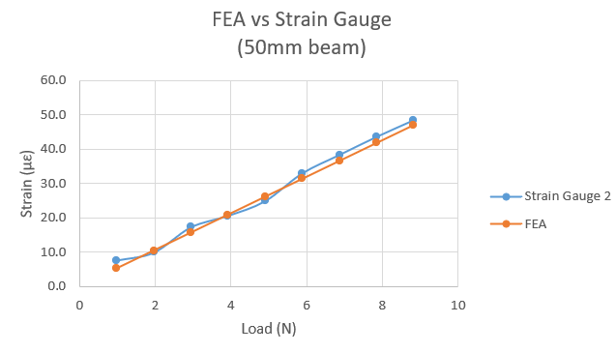

Figure 9. Comparison of strain gauge 5 results and FEA predictions for 50mm beam

|  |  |  |  |  |  |
| --- | --- | --- | --- | --- | --- |
| **Load (g)** | **Load (N)** | **Gauge 2 (µε)** | **FEA (µε)** | **Difference  (µε)** | **Difference (%)** |
| 100 | 0.981 | 7.7 | 5.2 | -2.5 | -32% |
| 200 | 1.962 | 10.0 | 10.4 | 0.5 | 5% |
| 300 | 2.943 | 17.3 | 15.7 | -1.6 | -9% |
| 400 | 3.924 | 20.6 | 20.9 | 0.3 | 1% |
| 500 | 4.905 | 24.8 | 26.1 | 1.3 | 5% |
| 600 | 5.886 | 32.9 | 31.3 | -1.5 | -5% |
| 700 | 6.867 | 38.2 | 36.6 | -1.7 | -4% |
| 800 | 7.848 | 43.5 | 41.8 | -1.7 | -4% |
| 900 | 8.829 | 48.3 | 47.0 | -1.3 | -3% |

Table 9. Comparison of strain gauge 5 results and FEA predictions for 50mm beam

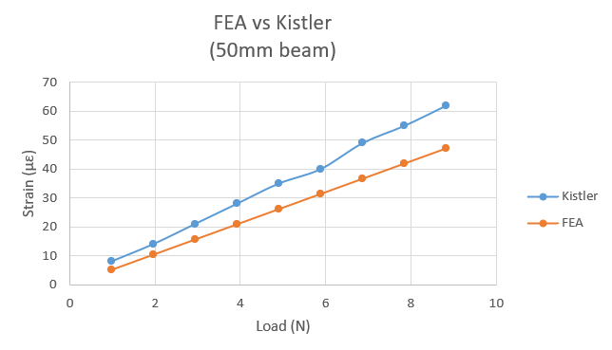**Kistler on 50mm beam (From 13.02.24)**

Figure 10. Comparison of Kistler results and FEA predictions for 50mm beam

|  |  |  |  |  |  |
| --- | --- | --- | --- | --- | --- |
| **Load (g)** | **Load (N)** | **Kistler (µε)** | **FEA (µε)** | **Difference  (µε)** | **Difference (%)** |
| 100 | 0.981 | 8 | 7.6 | -0.4 | -5% |
| 200 | 1.962 | 14 | 15.0 | 1.0 | 7% |
| 300 | 2.943 | 21 | 22.5 | 1.5 | 7% |
| 400 | 3.924 | 28 | 29.9 | 1.9 | 7% |
| 500 | 4.905 | 35 | 37.3 | 2.3 | 7% |
| 600 | 5.886 | 40 | 44.7 | 4.7 | 12% |
| 700 | 6.867 | 49 | 52.2 | 3.2 | 6% |
| 800 | 7.848 | 55 | 59.6 | 4.6 | 8% |
| 900 | 8.829 | 62 | 67.0 | 5.0 | 8% |

Table 10. Comparison of Kistler results and FEA predictions for 50mm beam

Note that Kistler results for 50mm beam are different to the ones I shared yesterday- an error was spotted in the previous version.

**Conclusions**

The Kistler results agree reasonably closely with the FEA- to within 7% for the 25mm beam and to within 12% for the 50mm beam. The accuracy improves as strain increases, and it's consistently accurate to within 3% when more than 35 microstrain is exhibited.

One of the axial strain gauges on the 25mm beam is quite similar to the FEA predictions (gauge 2), the other is off by 70% (gauge 5). I've already accounted for the fact that they are located in different positions in the FEA so I'm not sure why this is. Later found out that it was because the beam was bending in a different direction to what was expected- the strain gauge oriented in a direction thought to be non-optimal actually captured the strain associated with this.

The gauges oriented in the other directions give unusual results- much higher than you'd expect. Same story here- see later experiments

The Poisson ratio comes out to between 0.38 and 0.49 for the 0/90 degree rosette on this beam- much too high?

The only gauge running along the axis of the 50mm beam (gauge 2) closely aligns with predicted values- within 5% when more than 20 microstrain is exhibited. Gauges 1 and 3 record values which are lower than this- as expected.